**For the main part it's looking good**

1. Can we have the currency in Euro
2. Can the View Stock button be linked to the Stock page

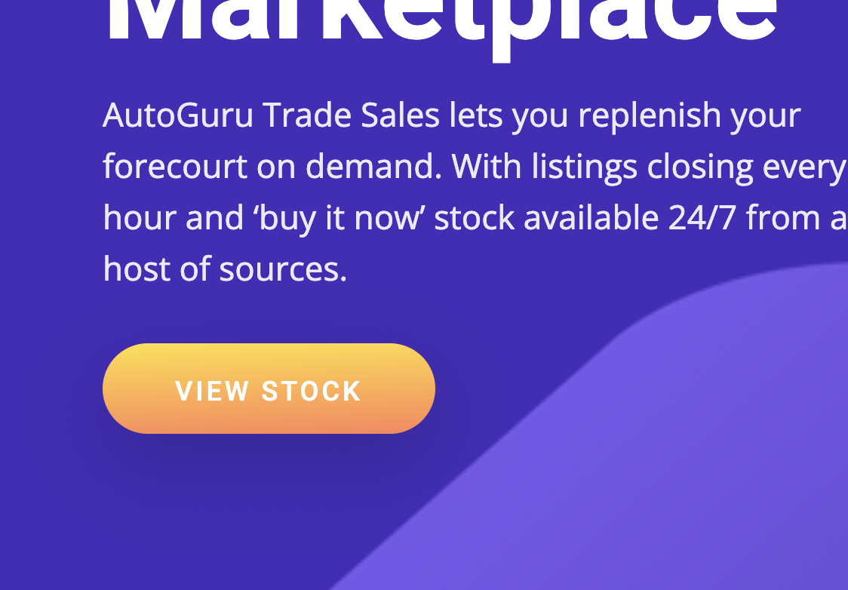

1. Can the view all button above also take them to the stock page

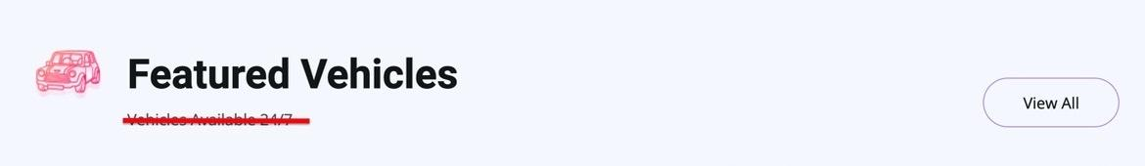

1. Can you check the Buy with confidence image layout on mobile view, the text is pulling through to the left on mobile.
2. Convenience section.

Can you add the below image of the delivery truck into the convenience section, ill attached it to an email.

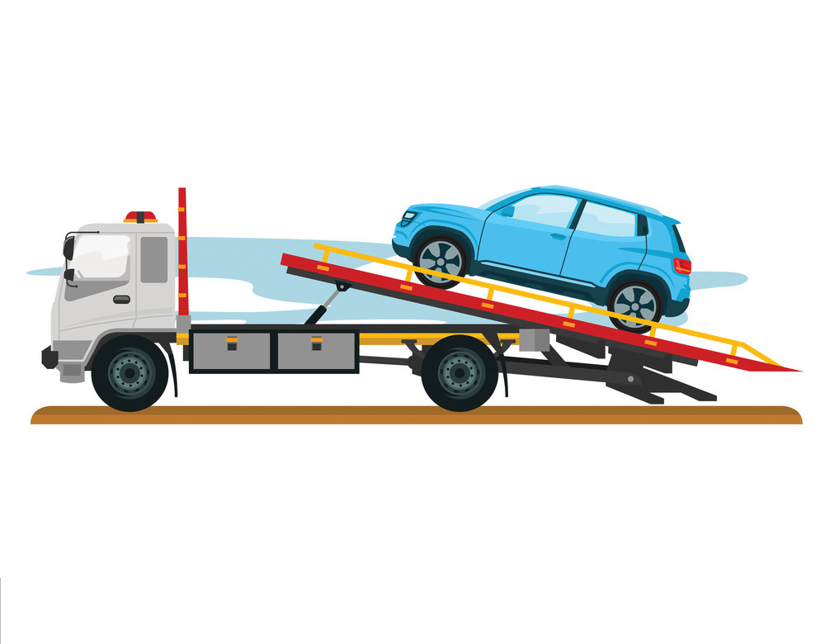

6. Listings page

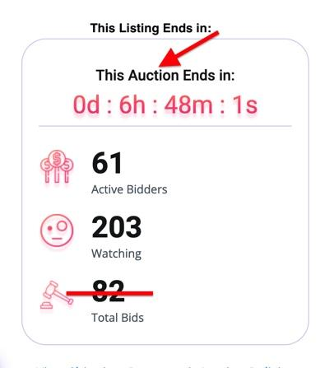

Can you change the text of Active Bidders to Active Offers”

Question: Do you think it would be possible for the admin to change the Active Offers and Watching numbers in the admin panel? If its too complicated we can remove them to simplify it.

We will provide text for the below down the line

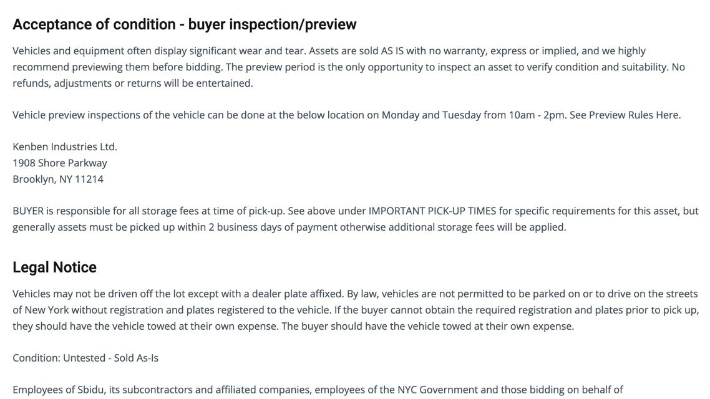

7. FAQ page

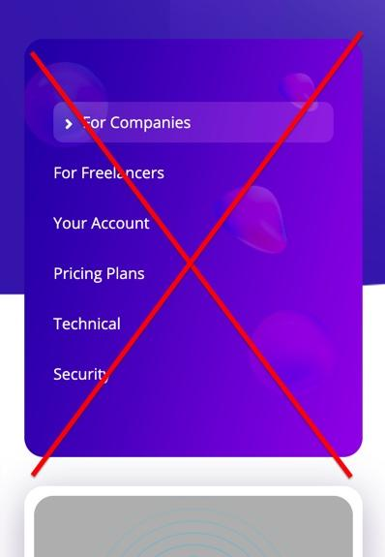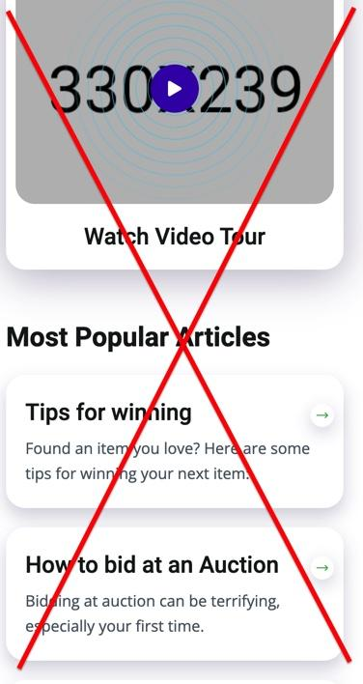

8. Dashboard

We can discuss this when we have a call on the admin / backend section

* **User Dashboard**

If a user click dashboard button in menu before log in, the alert will show. “Please log in firstly”.

User infos for sign up will be name, birthday, address, email, mobile, password and so on.

And user offer history will be saved in database.

* **Admin Dashboard**

There will be a log in windows with password input to check admin.

**Form for upload new car.**

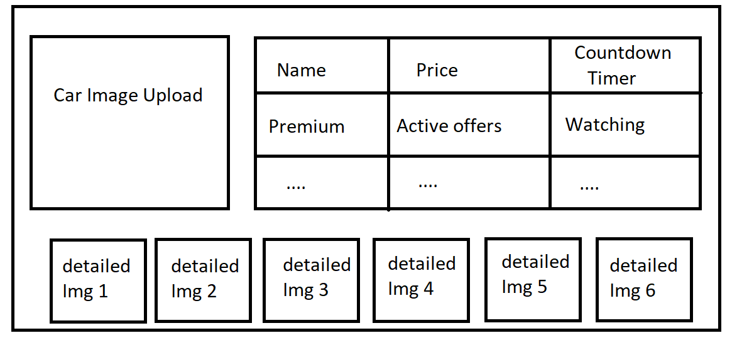

**Car management list**

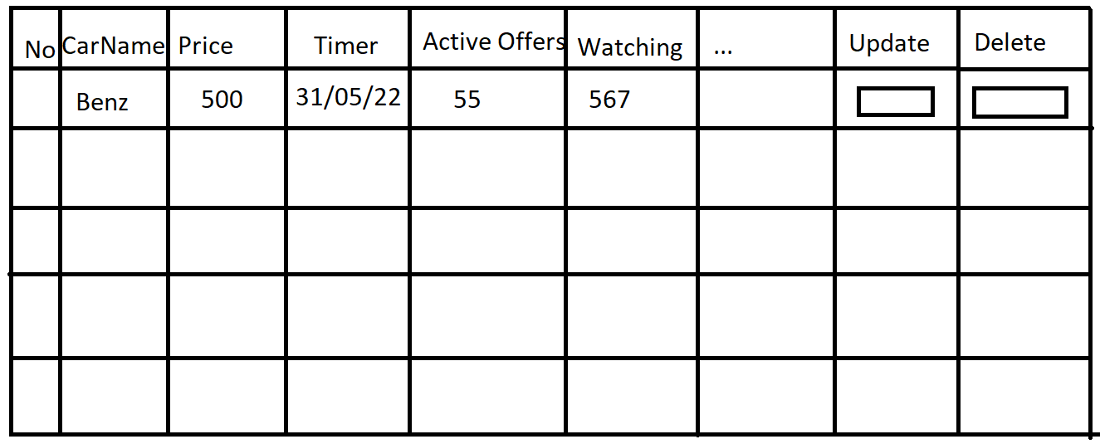

**User management List**

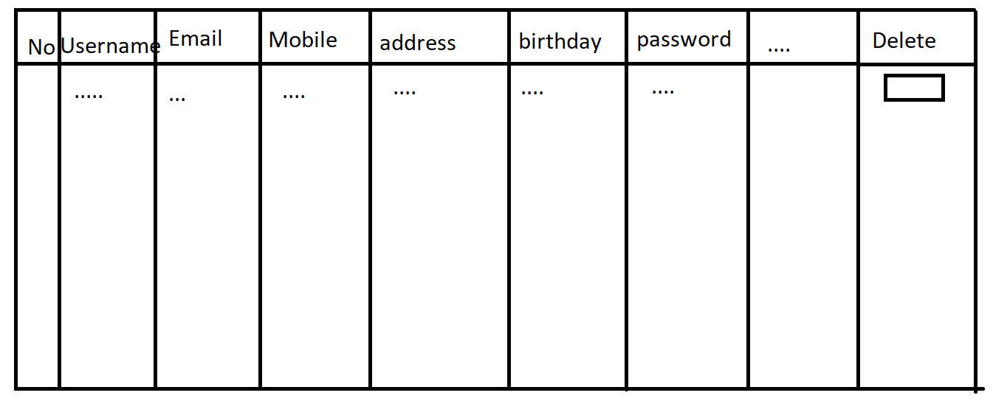

All the data will be saved in MySQL database.